LIFAT (EA 6300 –ERL CNRS 7002)
https://lifat.univ-tours.fr/

Brief description
The Laboratory of Fundamental and Applied Computer Science of Tours - France (LIFAT) is a research laboratory of the University of Tours and of the INSA Centre-Val de Loire.
The research fields developed inside the LIFAT are concerned with the design and implementation of new computational models and algorithms to solve data science and artificial intelligence challenges of today and tomorrow.

For that purpose, the LIFAT members have strong skills and expertise in several scientific fields such as data mining, data vizualisation, machine learning, computer vision, text mining and combinatorial optimisation. The obtained theoretical results are applied in 3 main domains that are Digital Humanities, Big Data and High Computing and the Health and Disability sector.

LIFAT is currently structured into 3 research teams with different specificities as illustrated in figure 1. Among these 3 research teams, LIFAT includes a CNRS ERL (ERL 7002) specialized in the field of optimization and complex problem solving.

An Internal Transfer Centre (ILIAD3) dedicated to the dissemination of research results is associated to the lab. It offers 3D digitization, computer development and IT consultancy services on the basis of the LIFAT skills and expertise.

The laboratory participates in several international projects or consortiums, as well as many national or regional projects. The laboratory also has a solid experience in industrial partnerships (CIFRE and collaborations).

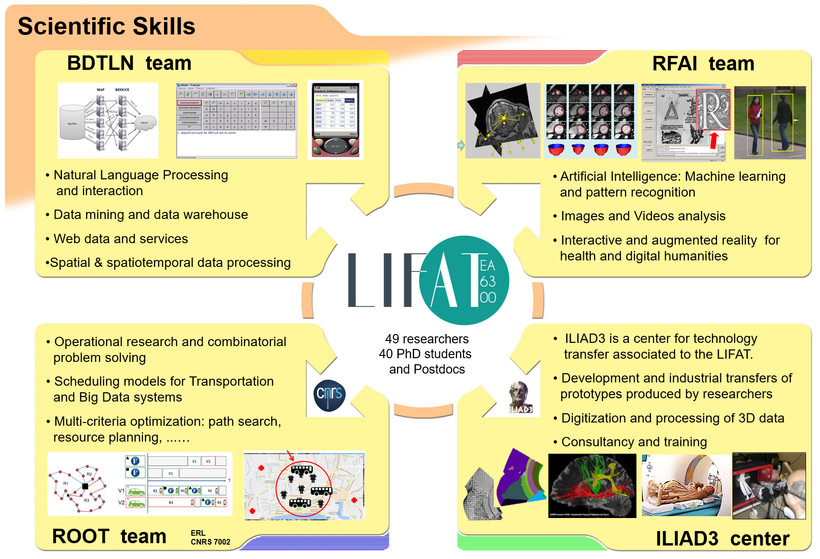
Figure 1: Structuration and scientific skills of the LIFAT

Key figures

LIFAT (EA 6300) has 49 permanent staff (including 20 HDR), 31 PhD students (including 7 CIFRE) and 10 engineers or post-docs.

LIFAT is currently involved in 2 international projects, 7 ANR projects and more than 10 projects funded by the Centre Val de Loire region.

The average annual activity of LIFAT is an annual flow of 6 to 8 PhD theses and 1 HDR, 4 books or participations in books, 20 international journals, 45 international conferences with reading committees and proceedings, 8 national conferences with reading committees and proceedings.

https://tel.archives-ouvertes.fr/LIFAT/

